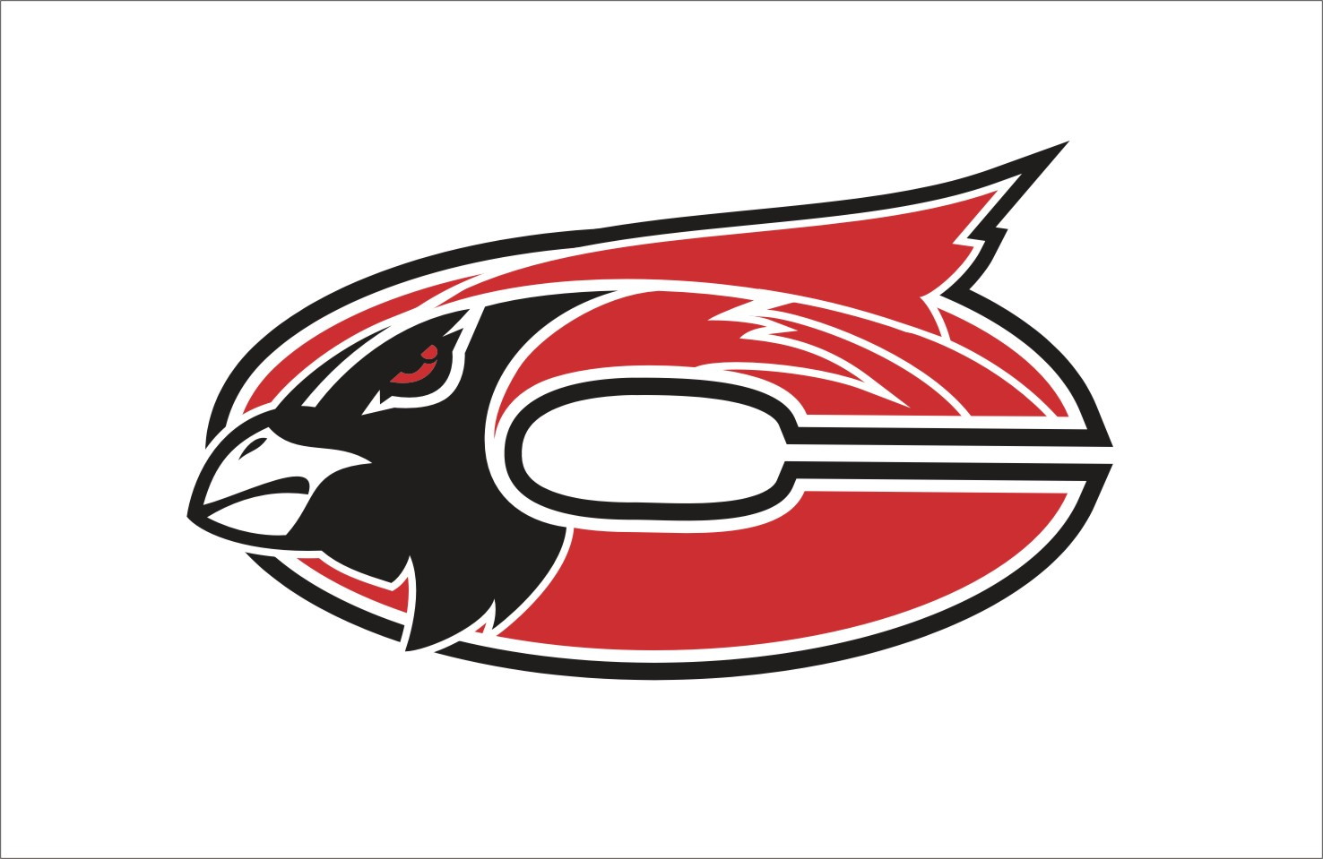

MISSION
The Faculty and staff of Chadwick R-1 Schools in partnership with parents and the community, will establish high standards of learning and high expectations for achievement while providing comprehensive guidance for success.

Subject:
Art Explore
Grade Level:
7th-8th

Grade: 7th-8th Subject: Art Explore

Time Period | GLE/  MO Standard/  Common Core | Description and Assessments | Notes--
Quarter: Only have these students for one quarter so assignments are completed in this order every quarter.

 | GLEs:  Strand I: 1C, Grade 7, 8  Strand II: 1A, Grade 8  Strand II: 1B, Grade 8  Strand II: 1D, Grade 7,8  MO Standards:  FA 1  FA 2  DOK:  Level 1  Level 2  Level 4  CC Standards for English/Writing:  SL 1,2,6 | Computerized Artwork  - Create a composition of lines and shapes using general software – www.sumopaint.com  - Differentiate between geometric and organic shapes  - Use a variety of lines and line quality, shapes, textures, tools, values, etc. to create non-objective artwork  Pre-Project Assessment:  - Pre-test on lines, shapes, texture and value  - Question/Answer  - Group discussion  Mid-Project Assessment:  - Conference with students individually as they work  Post-Project Assessment:  - Finished project  - Conference with students individually about project
 | GLEs:  Strand I: 1A, Grade 8  Strand I, 3A, Grade 7  Strand II: 1C, Grade 8  Strand II: 1F, Grade 8  Strand II: 2C, Grade 8  Strand II: 2F, Grade 8  MO Standards:  FA 1  FA 2  DOK:  Level 1  Level 2  CC Standards for English/Writing:  SL 1,2,6 | Value Scale/Shaded Form Still Life  - Create continuous, graduated and even tones using pencil and colored pencil  - Identify and use a range of values to create value contrast  - Create a still life from observation  - Identify and use a range of values to create the illusion of form  - Use appropriate scale relationship  - Differentiate between shapes and forms.  Pre-Project Assessment:  - Question/Answer  - Value Scale Example completion  Mid-Project Assessment:  - Conference with students individually as needed during work time  Post-Project Assessment:  - Finished project  - Question/Answer  - Conference with students individually as needed
 | GLEs:  Strand I: 1A, grade 7  Strand I: 3A, grade 8  Strand I: 3C, grade 7,8  Strand II: 1D, grade 7  MO Standards:  FA1  FA 2  DOK:  Level 1  Level 2  Level 4  CC Standards for English/Writing:  SL 1,2,6 | Outdoor Textured Landscape Drawing  - Use a pencil to create simulated/implied textures  - Create a realistic drawing of a landscape  - Observe and draw nature/environment  - Define and differentiate between implied, simulated, real and invented textures.  - Understand and Use foreground, middle ground, background and space in artwork  Pre-Project Assessment:  - Question/Answer as group  Mid-Project Assessment:  - Conference with students individually as needed during work time  - Question/Answer  Post-Project Assessment:  - Finished project  - Quesiton/Answer  - Class critique/discussion
 | GLEs:  Strand I: 3A  Strand I: 3C  Strand V: 1A  MO Standards:  FA 1  FA 5  DOK:  Level 1  Level 2  Level 3  CC Standards for English/Writing:  SL 1,2,6 | Abstract Landscape  - Design a landscape using an abstract method  Pre-Project Assessment:  - Questionnaire on abstract vs. realistic  - Question/Answer as group  Mid-Project Assessment:  - Conference with students individually as needed during work time  Post-Project Assessment:  - Finished project  - Question/Answer  - Class critique/discussion
 | GLEs:  Strand II: 1G, grade 8  Strand V: 1A, grade 7, 8  MO Standards:  FA 2  FA 5  DOK:  Level 1  Level 2  Level 3  Level 4  CC Standards for English/Writing:  SL 1,2,6 | One Point Perspective Room Drawing  - Create a one point perspective drawing of a room  - Use converging lines, vertical and horizontal lines, vanishing point  - Use ruler to create straight lines and precise angles  - Define vanishing point, converging line, horizon line, parallel and perpendicular  Pre-Project Assessment:  - Pre-project quiz on perspective drawing  - Question/Answer  - Individual students complete perspective drawing example sheet as class before starting project  Mid-Project Assessment:  - Consult with individual students as needed during work time  - Question/answer  Post-Project Assessment:  - Finished project  - Class critique/discussion
 | GLEs:  Strand II: 1A, grade 8  Strand II: 1B, grade 8  Strand II: 2A, grade 7  Strand II: 2B, grade 7  MO Standards:  FA 2  DOK:  Level 1  Level 2  Level 3  Level 4  CC Standards for English/Writing:  SL 1,2,6 | Mandalas (Symmetrical and Radial Design)  - Identify and use radial balance, symmetrical balance  - -Identify and use focal point  - -Identify and use varied line quality  - -Identify and use varied shapes, lines, patterns to create repetition  - Define symmetry, radial balance, central axis, radius, diameter, circumference  Pre-Project Assessment:  - Have students complete questionnaire on balance before starting lesson to find out what they know  - Question/Answer  Mid-Project Assessment:  - Conference with students individually as needed during work time  - Question/Answer  Post-Project Assessment:  - Finished project  - Quiz on balance
 | GLEs:  Strand II: 2A, grade 8  MO Standards:  FA 2  DOK:  Level 1  Level 2  Level 3  Level 4  CC Standards for English/Writing:  SL 1,2,6 | Asymmetrical Fashion Design  - Design a fashion item that shows asymmetrical balance.  Pre-Project Assessment:  - Question/Answer  Mid-Project Assessment:  - Conference with students individually as needed during work time  Post-Project Assessment:  - Finished project  - Self-critique and discussion
 | GLEs:  Strand I: 1D, grade 7,8  Strand I: 3B, grade 8  Strand II: 1B, grade 7,8  Strand II: 2D, grade 7,8  MO Standards:  FA 1  FA 2  DOK:  Level 1  Level 2  Level 3  Level 4  CC Standards for English/Writing:  SL 1,2,6 | Recycled Magazine Coiled Pot  - Create a functional fiber made vessel using recycled materials  - Identify and use rhythmic lines and shapes  - Understand the Importance of Recycling materials for art instead of polluting environment  Pre-Project Assessment:  - Questionnaire about recycled art  - Question/Answer  - Class discussion  Mid-Project Assessment:  - Consult with students individually as needed during work time  Post-Project Assessment:  - Finished project
 | GLEs:  Strand I: 2A  MO Standards:  FA 1  DOK:  Level 1  Level 2  Level 3  Level 4  CC Standards for English/Writing:  SL 1,2,6 | Soap Carving  - Use proper techniques to create a sculpture from a subtractive carving process.-soap carving  Pre-Project Assessment:  - Question/Answer  Mid-Project Assessment:  - Consult with students individually as needed during work time  Post-Project Assessment:  - Finished project  - Question/Answer  - Self-critique and discussion
 | GLEs:  Strand I: 1D, Grade 7,8  Strand II: 1E, Grade 7,8  MO Standards:  FA 1  FA 2  DOK:  Level 1  Level 2  Level 3  Level 4  CC Standards for English/Writing:  SL 1,2,6 | Printmaking  - 8th grade  - -Demonstrate a printmaking process using a variety of ink colors- styrofoam relief prints  - Use complementary colors  - 7th grade  - -Demonstrate a type of relief block printmaking- styrofoam relief prints  - Use analogous colors  - Differentiate between high low relief  Pre-Project Assessment:  - Pre-test on printmaking  - Question/Answer  Mid-Project Assessment:  - Consult with students individually as needed during work time  Post-Project Assessment:  - Finished project  - Printmaking quiz
 | GLEs:  Strand I: 2A, grade 7,8  Strand I: 3B, grade 8  Strand II: 1G, grade 7  Strand V: 1A, grade 7, 8  MO Standards:  FA 1  FA 2  FA 5  DOK:  Level 1  Level 2  Level 3  Level 4  CC Standards for English/Writing:  SL 1,2,6 | Clay Project  - 7th grade  - Create an in-the-round artwork by joining two or more surfaces  - Identify and use positive and negative forms in three-dimensional work  - Identify artwork from Europe, United States  - 8th grade  - Modeling with clay or similar material: create a 3D artwork demonstrating appropriate joining techniques  - Create an original functional object  - Identify artwork from United States, Native American culture  Pre-Project Assessment:  - KWL Chart as class  - Pre-test on clay and clay building processes  - Question/Answer  Mid-Project Assessment:  - Question/Answer  - Consult with students individually as needed during work time  Post-Project Assessment:  - Finished project  - Class critique and discussion  - Question/Answer  - Ceramics test
 | GLEs:  Strand I: 2A  Strand I: 3C  Strand II: 2D  MO Standards:  FA 2  DOK:  Level 1  Level 2  Level 4  CC Standards for English/Writing:  SL 1,2,6 | Duct Tape Project  - Create a sculpture in the round by using an additive process  - Layer materials to create more thickness  - Identify and use regular and progressive rhythm  Pre-Project Assessment:  - Question/Answer  Mid-Project Assessment:  - Consult with students individually as needed during work time  - Question/Answer  Post-Project Assessment:  - Finished project
 | GLEs:  Strand IV: 2A, Grade 7  Strand V: 1A, Grade 7  MO Standards:  FA 4  FA 5  DOK:  Level 1  Level 2  Level 3  Level 4  CC Standards for English/Writing:  SL 1,2,6 | Text and Illustration  - 6th grade  - Illustrate text  - Using opaque paint, overlap brush strokes to create a smooth and even area of color  - Identify and use complex shapes such as people, animals, vehicles  - 7th grade  - Explain the relationship between illustration and written text.  - Identify works of art from Europe  Pre-Project Assessment:  - Question/Answer  Mid-Project Assessment:  - Consult with students individually as needed during work time  Post-Project Assessment:  - Finished project  - Share time with class and discussion
 | GLEs:  Strand IV: 1A, Grade 8  MO Standards:  FA 4  DOK:  Level 1  Level 2  Level 3  CC Standards for English/Writing:  RI 1  W 1,2,4  SL 1,2,6 | Music and Art Connection  - 8th grade-  - Compare and contrast examples of American art and music  Pre-Project Assessment:  - Compare and contrast example as class on board  - Question/Answer  Mid-Project Assessment:  - Consult with students individually as needed during project  Post-Project Assessment:  - Finished chart and explanation
 | GLEs:  Strand III: 2A  Strand V: 1A  Strand V: 1B  MO Standards:  FA 3  FA 5  DOK:  Level 1  Level 2  Level 3  Level 4  CC Standards for English/Writing:  RI 1  W 1,2,4  SL 1,2,6 | Art Criticism  - Describe the artwork and the subject matter in detail  - Analyze the use of Elements and Principles in artwork  - Interpret the meaning of an artwork  - Judge and artwork  - Identify works of art from the United States and Europe  - Compare and Contrast 2 artworks on : time, place, theme, subject matter, materials, characteristics and cultural contexts  Pre-Project Assessment:  - Do example as class  Mid-Project Assessment:  - Consult students individually as needed during work time  Post-Project Assessment:  - Finished Art Criticism  - Question/Answer

