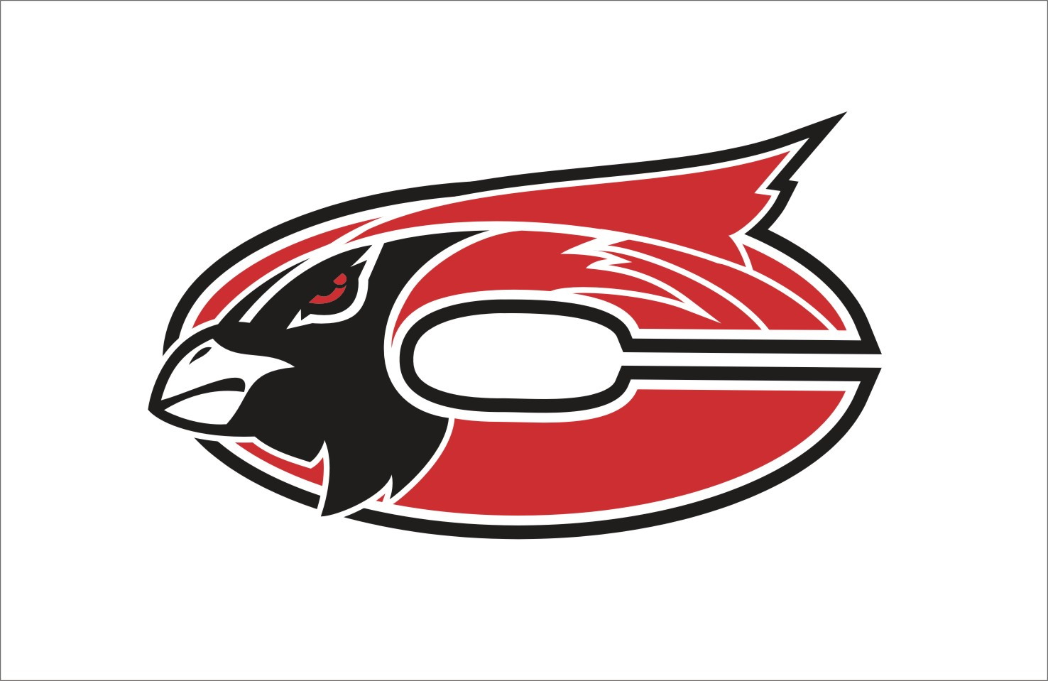

MISSION
The Faculty and staff of Chadwick R-1 Schools in partnership with parents and the community, will establish high standards of learning and high expectations for achievement while providing comprehensive guidance for success.

Subject:
Art
Grade Level:
4th

Grade:4th Subject: Art

Time Period | GLE/  MO Standard/  Common Core | Description and Assessments | Notes--
August: Lines, shapes and patterns.

August | GLEs:  Strand II: 1A  Strand II: 1B  MO STANDARDS:  FA 2  DOK:  Level 1  Level 2  Level 4  CC Standards for English/Writing:  SL 1,2,3 | Gustav Klimt Tree of Life Drawing  - Identify the works of Gustav Klimt  - Create an outline  - Identify and use organic/freeform shapes  - Compete tree of life drawing using a variety of patterns, lines and shapes.  Pre-Project Assessment:  - Question/Answer  - Pre-project worksheet on lines, shapes and patterns  Mid-Project Assessment:  - Conference with individual students as necessary during work time  Post-Project Assessment:  - Finished project  - Share time/Presentation of projects by students /Discussion as a class | Q&A time  Share time/Critique
September: Realistic and Abstract Portraits.

September | GLEs:  Strand I: 3A  Strand II: 2F  MO STANDARDS:  FA 1  FA 2  DOK:  Level 1  Level 2  Level 4  CC Standards for English/Writing:  SL 1,2,3 | Portrait Drawings  - Create a portrait  - Use proper proportions  - Make observations and include details in their artwork  Pre-Project Assessment:  - Question/Answer  Mid-Project Assessment:  - Conference with individual students as necessary during work time  Post-Project Assessment:  - Finished project  - Share time/Presentation of projects by students /Discussion as a class | Q&A time  Share time/Critique
September | GLEs:  Strand I: 3A  Strand V: 1A  MO STANDARDS:  FA 1  FA 5  DOK:  Level 1  Level 2  Level 4  CC Standards for English/Writing:  SL 1,2,3 | Mr. Picasso Head Portraits  - Recognize the work of Pablo Picasso  - Identify abstract art  - Create an abstract portrait drawing  - Create abstract portraits using Mr. Picasso Head internet game and smartboard  Pre-Project Assessment:  - Question/Answer  - Do example as class  Mid-Project Assessment:  - Conference with individual students as necessary during work time  Post-Project Assessment:  - Finished project  - Share time/Presentation of projects by students /Discussion as a class | Q&A time  Share time/Critique
September | GLEs:  Strand I: 3A  MO STANDARDS:  FA 1  DOK:  Level 1  Level 2  Level 4  CC Standards for English/Writing:  SL 1,2,3 | Shrinky Dink Caricatures  -exaggerate, distort, or simplify features to create an abstract portrait  Pre-Project Assessment:  - Question/Answer  Mid-Project Assessment:  - Conference with individual students as necessary during work time  Post-Project Assessment:  - Finished project  - Share time/Presentation of projects by students /Discussion as a class | Q&A time  Share time/Critique
October: Graphic Arts.

October | GLEs:  Strand I: 2A  MO STANDARDS:  FA 1  DOK:  Level 1  Level 2  Level 4  CC Standards for English/Writing:  SL 1,2,3 | Halloween Origami  - Identify the Japanese art of folding paper –origami  - Create folded paper artwork (origami)  Pre-Project Assessment:  - Question/Answer  Mid-Project Assessment:  - Conference with individual students as necessary during work time  Post-Project Assessment:  - Finished project  - Share time/Presentation of projects by students /Discussion as a class | Q&A time  Share time/Critique
October | GLEs:  Strand I: 3B  Strand I: 3C  Strand IV: 2A  Strand V: 1A  MO STANDARDS:  FA 1  FA 4  FA 5  DOK:  Level 1  Level 2  Level 3  Level 4  CC Standards for English/Writing:  W 2,4  SL 1,2,3,4 | Greeting Cards about Missouri  - Create a graphic art- greeting card  - Design a greeting card reflecting life in Missouri or Missouri  - Recognize artwork by George Caleb Bingham and Thomas Hart Benton  Pre-Project Assessment:  - Question/Answer  Mid-Project Assessment:  - Conference with individual students as necessary during work time  Post-Project Assessment:  - Finished project  - Share time/Presentation of projects by students /Discussion as a class | Q&A time  Share time/Critique
October | GLEs:  Strand I: 3B  Strand I: 3C  MO STANDARDS:  FA 1  DOK:  Level 1  Level 2  Level 3  Level 4  CC Standards for English/Writing:  W 1,2,4  SL 1,2,3,4 | Recycling Posters/Red Ribbon Week Posters  - Create a poster to go along with the theme “Recycling” -environment  - Discuss the variety of uses for posters  - Know history of posters  - Design an aesthetically pleasing poster using bold, colorful words, slogan, picture, etc.  Pre-Project Assessment:  - Question/Answer  - Make List as class on board regarding topic KWL Chart  Mid-Project Assessment:  - Conference with individual students as necessary during work time  Post-Project Assessment:  - Finished project  - Share time/Presentation of projects by students /Discussion as a class  - What I learned exit slip | Q&A time  Share time/Critique
November: Balance and Fiber Arts.

November | GLEs:  Strand II: 2A  Strand II: 2B  Strand V: 1A  MO STANDARDS:  FA 2  FA 5  DOK:  Level 1  Level 2  Level 3  Level 4  CC Standards for English/Writing:  SL 1,2,3 | Radial Balance Stained Glass Design  - Identify stained glass designs from European cathedrals  - Create a radial balanced design using lines, shapes, colors and patterns  - Identify and create a center of interest-focal point  - Define focal point  Pre-Project Assessment:  - Question/Answer  Mid-Project Assessment:  - Project sample sheet  - Conference with individual students as necessary during work time  Post-Project Assessment:  - Finished project  - Share time/Presentation of projects by students /Discussion as a class | Q&A time  Share time/Critique
November | GLEs:  Strand I: 1D  MO STANDARDS:  FA 1  DOK:  Level 1  Level 2  Level 4  CC Standards for English/Writing:  SL 1,2,3 | Weaving  - Create a Weaving Using a Simple Loom  - Show an AB pattern  - Define warp, weft, loom, shuttle, etc.  Pre-Project Assessment:  - Question/Answer  Mid-Project Assessment:  - Conference with individual students as necessary during work time  Post-Project Assessment:  - Finished project  - Share time/Presentation of projects by students /Discussion as a class | Q&A time  Share time/Critique
December: Relief Artwork/Sculpture

December | GLEs:  Strand I: 2A  Strand II: 1C  MO STANDARDS:  FA 1  FA 2  DOK:  Level 1  Level 2  Level 3  Level 4  CC Standards for English/Writing:  SL 1,2,3 | Relief Robot Sculpture  -Build or layer materials to create a relief sculpture of a robot  Pre-Project Assessment:  - Question/Answer  Mid-Project Assessment:  - Conference with individual students as necessary during work time  Post-Project Assessment:  - Finished project  - Share time/Presentation of projects by students /Discussion as a class | Q&A time  Share time/Critique
January: Still Life Unit

January | GLEs:  Strand II: 1A  Strand II: 1G  Strand III: 2A  Strand V: 1A  Strand V: 1B  MO STANDARDS:  DOK:  Level 1  Level 2  Level 3  Level 4  CC Standards for English/Writing:  RI 1,2,3,4,5,6,7,8,9  W 1,2,4  SL 1,2,3,4 | The Still Life: Working with Space  - Determine the meaning of words and phrases  - Integrate information in several formats  - Write arguments using reason and evidence  - Read and comprehend material about the arts  Pre-Project Assessment:  - Question/Answer  - Vocabulary pre-test  Mid-Project Assessment:  - Conference with individual students as necessary during work time  Post-Project Assessment:  - Finished project  - Share time/Presentation of projects by students /Discussion as a class  - Vocabulary quiz | Q&A time  Share time/Critique
January | DOK:  Level 1  Level 2  Level 3  CC Standards for English/Writing:  RI 1,2,3,4,5,7,8  W 1,4  SL 1,2,3,4 | Debate: The Stolen Matisse Scandal  - Cite textual evidence  - Determine the main idea of a reading selection  - Analyze details that connect events  - Trace arguments and evidence  - Formulate an argument and deliver it to the class  Pre-Project Assessment:  - Question/Answer  - Practice run as class on board with another “case”  Mid-Project Assessment:  - Conference with individual students as necessary during work time  Post-Project Assessment:  - Finished written argument/Deliver argument to class as presentation  - Question/Answer and Discussion | Q&A time  Share time/Critique
January | GLEs:  Strand I: 1 A  Strand I: 3A  Strand II: 1A  Strand II: 1B  Strand II: 1D  Strand II: 1E  Strand II: 1F  Strand II: 1G  Strand II: 2C  MO STANDARDS:  FA 1  FA 2  DOK:  Level 1  Level 2  Level 4  CC Standards for English/Writing:  SL 1,2,3 | Develop a Still Life  - Create a still life drawing that will demonstrate an understanding of creating 3D space  - Select and use oil pastels to color both the foreground and background  - Define foreground, middle ground and background  Pre-Project Assessment:  - Question/Answer  Mid-Project Assessment:  - Conference with individual students as necessary during work time  Post-Project Assessment:  - Finished project  - Share time/Presentation of projects by students /Discussion as a class | Q&A time  Share time/Critique
January | GLEs:  Strand I: 1A  Strand I: 3A  Strand II: 1A  Strand II: 1E  Strand II: 1F  Strand II: 1G  Strand V: 1A  MO STANDARDS:  FA 1  DOK:  Level 1  Level 2  Level 4  CC Standards for English/Writing:  SL 1,2,3 | Abstract Still Life Drawing  - Create an abstract still life drawing demonstrating an understanding of Cubism, value and space.  Pre-Project Assessment:  - Question/Answer  Mid-Project Assessment:  - Conference with individual students as necessary during work time  Post-Project Assessment:  - Finished project  - Share time/Presentation of projects by students /Discussion as a class | Q&A time  Share time/Critique
February: Painting Lessons. Color Usage.

February | GLEs:  Strand I: 1B  Strand II: 1E  Strand II: 1F  Strand II: 1G  Strand II: 2C  MO STANDARDS:  FA 1  FA 2  DOK:  Level 1  Level 2  Level 4  CC Standards for English/Writing:  SL 1,2,3 | Hot Air Balloon Parade in the Sky  - Use placement and change in detail to show illusion of space  - Use tempera paints to create tints and shades  - Use value contrast  - Create a value scale  - Use proper painting procedures  Pre-Project Assessment:  - Question/Answer  Mid-Project Assessment:  - Conference with individual students as necessary during work time  Post-Project Assessment:  - Finished project  - Share time/Presentation of projects by students /Discussion as a class | Q&A time  Share time/Critique
February | GLEs:  Strand I: 1B  Strand I: 3A  MO STANDARDS:  FA 1  DOK:  Level 1  Level 2  Level 4  CC Standards for English/Writing: :  SL 1,2,3 | Watercolor Seascape  - Design a seascape  - Create a watercolor resist  - Apply watercolors to an artwork-wash  - Apply watercolor paint to wet areas to blend color ( wet-on-wet technique).  Pre-Project Assessment:  - Question/Answer  Mid-Project Assessment:  - Conference with individual students as necessary during work time  Post-Project Assessment:  - Finished project  - Share time/Presentation of projects by students /Discussion as a class | Q&A time  Share time/Critique
March: Misc. Lessons.

March | GLEs:  Strand II: 1G  MO STANDARDS:  FA 2  DOK:  Level 1  Level 2  Level 3  Level 4  CC Standards for English/Writing:  SL 1,2,3 | Optical Illusions  - Create an optical illusion using lines, shapes and color contrast  - Identify the work of mc escher  - Identify positive and negative space  Pre-Project Assessment:  - Question/Answer  Mid-Project Assessment:  - Conference with individual students as necessary during work time  Post-Project Assessment:  - Finished project  - Share time/Presentation of projects by students /Discussion as a class | Q&A time  Share time/Critique
March | GLEs:  Strand IV: 1A  MO STANDARDS:  FA 4  DOK:  Level 1  Level 2  Level 3  Level 4  CC Standards for English/Writing:  W 3,4  SL 1,2,3 | Artwork Alive  - -Explain how a play or skit could be inspired by a work of art (e.g., painting or statue)  - Participate in writing and acting out a skit as a group  Pre-Project Assessment:  - Question/Answer  Mid-Project Assessment:  - Conference with individual students/groups as necessary during work time  Post-Project Assessment:  - Finished presentation  - Share time/Discussion as a class | Q&A time  Share time/Critique
April: Ceramics and Art Criticism.

April | GLEs:  Strand I: 2A  Strand I: 3C  Strand II: 1C  MO STANDARDS:  FA 1  FA 2  DOK:  Level 1  Level 2  Level 4  CC Standards for English/Writing:  SL 1,2,3 | Clay Flowers  - Make an organic form from clay  - Use appropriate clay building/joining techniques  - Use correct ceramics terminology  Pre-Project Assessment:  - Question/Answer  - Pre-test on clay and procedures  Mid-Project Assessment:  - Conference with individual students as necessary during work time  Post-Project Assessment:  - Finished project  - Share time/Presentation of projects by students /Discussion as a class | Q&A time  Share time/Critique
April | GLEs:  Strand III: 1A  Strand III: 2A  MO STANDARDS:  FA 3  DOK:  Level 1  Level 2  Level 3  Level 4  CC Standards for English/Writing:  RI 1,2,3,4  W 1,2,4  SL 1,2,3,4 | Art Criticism  - Answer questions about art:  - What is art?  - What is beauty?  - Does all art have to be beautiful?  - Describe elements and principles in artwork  Pre-Project Assessment:  - Question/Answer  Mid-Project Assessment:  - Conference with individual students as necessary during work time  Post-Project Assessment:  - Finished art criticism paper  - Share time/Discussion as a class | Q&A time  Share time/Critique
April | GLEs:  Strand V: 1B  Strand III: 2A  MO STANDARDS:  FA 3  FA 5  DOK:  Level 1  Level 2  Level 3  Level 4  CC Standards for English/Writing:  RI 1,2,3,4  W 1,2,4  SL 1,2,3,4 | Compare and Contrast Art  - Compare and contrast two artworks on: Subject matter, Media, Use of value and space, theme, purpose of art in culture, place  - Describe the use of the following in artworks: Outlines, Organic shapes, Organic forms, Tints and shades, Values, Positive and negative space, Radial balance, Center of interest/focal Point, Contrast/ variety of values, Complex patterns, Facial proportions  Pre-Project Assessment:  - Question/Answer  - Do example as class – compare and contrast chart  Mid-Project Assessment:  - Conference with individual students as necessary during work time  Post-Project Assessment:  - Finished compare/contrast project  - Share time/Presentation of projects by students /Discussion as a class | Q&A time  Share time/Critique
May:

May | Varies | Extra Projects  - Varies

