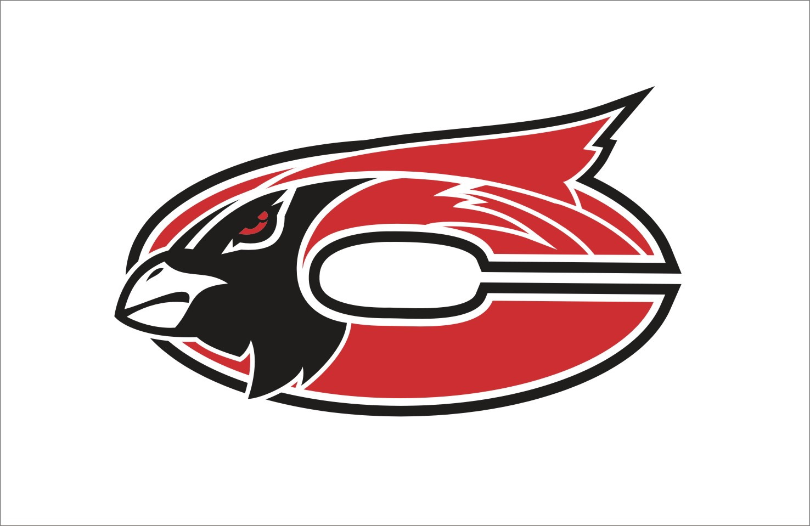

MISSION
The Faculty and staff of Chadwick R-1 Schools in partnership with parents and the community, will establish high standards of learning and high expectations for achievement while providing comprehensive guidance for success.

Subject:
Art
Grade Level:
3rd Grade

Grade:3 Subject: Art

Time Period | GLE/  MO Standard/  Common Core | Description | Notes--
August: Introduce/Review Lines, Shapes and Forms
August | GLEs:  Strand I: 1A  Strand I: 1B  Strand I: 3A  Strand II: 1A  Strand II: 1B  Strand III: 1A  Strand V: 1A  MO STANDARDS:  FA 1  FA 2  DOK:  Level 1  Level 2  Level 3  Level 4  CC Standards for English/Writing:  SL 1,2,3 | Non-Objective Watercolor Resist  - Understand the term “non-objective artwork”  - Create a non-objective artwork using lines, shapes, colors, and patterns  - Define “Watercolor resist” and create a resist of their own  - Apply paint evenly over areas of artwork and create a wash  - Differentiate between shapes and forms  - Identify and use horizontal, vertical, diagonal lines  Pre-Project Assessment:  - Question/Answer  Mid-Project Assessment:  - Conference with individual students as necessary during work time  Post-Project Assessment:  - Finished project  - Share time/Presentation of projects by students /Discussion as a class
September: Continue Lines and Shapes. Introduce Color Theory and Warm/Cool colors.

September | GLEs:  Strand I: 1B  MO STANDARDS:  FA 1  DOK:  Level 1  Level 2  CC Standards for English/Writing:  SL 1,2,3 | Color Wheel  - Paint lines and shapes in with even color using tempera paint  - Put colors in the correct order  - Identify and use primary and secondary colors  - Mix colors to create other colors  Pre-Project Assessment:  - Question/Answer  - Worksheet on color and color mixing  Mid-Project Assessment:  - Conference with individual students as necessary during work time  Post-Project Assessment:  - Finished project  - Share time/Presentation of projects by students /Discussion as a class
September | GLEs:  Strand I: 1B  Strand II: 1A  Strand II: 1E  MO STANDARDS:  FA 1  FA 2  DOK:  Level 1  Level 2  Level 3  Level 4  CC Standards for English/Writing:  SL 1,2,3 | Jazzy Jungle Cats  - Paint lines and fill in shapes with even color tempera  - Identify and use warm and cool colors  - Use lines and basic shapes to create a jungle animal  - Identify the use of animals in African Art  Pre-Project Assessment:  - Question/Answer  Mid-Project Assessment:  - Conference with individual students as necessary during work time  Post-Project Assessment:  - Finished project  - Share time/Presentation of projects by students /Discussion as a class
September | GLEs:  Strand I: 3A  Strand II: 1E  MO STANDARDS:  FA 1  FA 2  DOK:  Level 1  Level 2  Level 4  CC Standards for English/Writing:  SL 1,2,3 | Warm/Cool Illusions  - Identify and use warm and cool colors  - Create a non-objective artwork  Pre-Project Assessment:  - Question/Answer  - Warm/cool color chart as class  Mid-Project Assessment:  - Conference with individual students as necessary during work time  Post-Project Assessment:  - Finished project  - Share time/Presentation of projects by students /Discussion as a class
October: Symmetry. Positive/Negative Space.

October | GLEs:  Strand I: 3A  MO STANDARDS:  FA 1  DOK:  Level 1  Level 2  Level 3  Level 4  CC Standards for English/Writing:  SL 1,2,3 | People in Action Drawings  - Create drawings of people in action poses  - Understand/define the word action  - Accurately portray human figure with joins, muscles, etc.  Pre-Project Assessment:  - Question/Answer  - Practice drawing as group-step by step  Mid-Project Assessment:  - Conference with individual students as necessary during work time  Post-Project Assessment:  - Finished project  - Share time/Presentation of projects by students /Discussion as a class
October | GLEs:  Strand I: 1D  Strand II: 2A  Strand IV: 2A  Strand V: 1A  MO STANDARDS:  FA 1  FA 2  FA 4  FA 5  DOK:  Level 1  Level 2  Level 3  Level 4  CC Standards for English/Writing:  RI 1,2,4  SL 1,2,3,4,6 | Symmetrical Masks  - Create an artwork using symmetrical balance  - Design a mask using what they have learned about symmetry  - Cut a symmetrical shape from folded piece of paper  - Demonstrate additive process  - Explain how the math principle of symmetry is used in art  - Identify works of Art from Africa  Pre-Project Assessment:  - Question/Answer  - Pre-project worksheet on symmetry  Mid-Project Assessment:  - Conference with individual students as necessary during work time  Post-Project Assessment:  - Finished project  - Share time/Presentation of projects by students /Discussion as a class
October | GLEs:  Strand I: 1D  Strand I: 2A  Strand II: 2A  Strand III: 1A  Strand IV: 2A  Strand V: 1A  MO STANDARDS:  FA 1  FA 2  FA 4  DOK:  Level 1  Level 2  Level 3  Level 4  CC Standards for English/Writing:  RI 1,2,4  SL 1,2,3 | Halloween Projects-Positive/Negative Space Pumpkin Collage  - Understand and use balance-symmetry  - Understand and use positive and negative space  - Cut a symmetrical shape from a folded piece of paper  - Glue all places down where they aren’t sticking up  - Identify and Define the “central axis”  - Identify Positive/Negative space artworks from a variety of countries  Pre-Project Assessment:  - Question/Answer  - Quiz on symmetry  Mid-Project Assessment:  - Conference with individual students as necessary during work time  Post-Project Assessment:  - Finished project  - Share time/Presentation of projects by students /Discussion as a class  - Quiz on symmetry
November: Continue Symmetry. Cultural artworks.

November | GLEs:  Strand I: 2A  Strand II: 2A  Strand IV: 2A  MO STANDARDS:  FA 1  FA 2  FA 4  DOK:  Level 1  Level 2  Level 3  Level 4  CC Standards for English/Writing:  RI 1,2,4  SL 1,2,3 | Symmetrical Notan Collage  - Identify the Japanese art of Notan  - Understand and Use organic shapes  - Understand and use balance-symmetry  - Understand and use positive and negative space  - Cut a symmetrical shape from a folded piece of paper  Pre-Project Assessment:  - Question/Answer  - Quiz on symmetry  Mid-Project Assessment:  - Conference with individual students as necessary during work time  Post-Project Assessment:  - Finished project  - Share time/Presentation of projects by students /Discussion as a class  - Quiz on symmetry
November | GLEs:  Strand I: 1D  Strand II: 1A  Strand II: 1B  MO STANDARDS:  FA 1  FA 2  DOK:  Level 1  Level 2  Level 4  CC Standards for English/Writing:  SL 1,2,3 | Dhurrie Rugs  - Work as a group to complete an artwork  - Create a cut paper collage  - Demonstrate an additive process  - Identify works of art from India  - Use a variety of lines and shapes  Pre-Project Assessment:  - Question/Answer  Mid-Project Assessment:  - Conference with individual students/groups as necessary during work time  Post-Project Assessment:  - Finished project  - Share time/Presentation of projects by students /Discussion as a class
November | Varies | Thanksgiving Project  -Varies by year
December: Paper Mache- Additive Process

December | GLEs:  Strand I: 1B  Strand I: 1D  Strand I: 2A  Strand I: 3A  Strand II: 1A  Strand II: 1C  Strand II: 1B  MO STANDARDS:  FA 1  FA 2  DOK:  Level 1  Level 2  Level 4  CC Standards for English/Writing:  SL 1,2,3 | Paper Mache Bowl  - Paint lines and fill in shapes with even color using tempera paint  - Demonstrate an additive process-paper mache  - Manipulate paper to create forms  - Create an original artwork using line, shape, color  - Create sculpture in the round  Pre-Project Assessment:  - Question/Answer  Mid-Project Assessment:  - Conference with individual students as necessary during work time  Post-Project Assessment:  - Finished project  - Share time/Presentation of projects by students /Discussion as a class
December | Varies | Christmas Projects  -Varies
January: Projects about family, community and self.

January | GLEs:  Strand I: 3C  MO STANDARDS:  FA 1  DOK:  Level 1  Level 2  Level 3  Level 4  CC Standards for English/Writing:  W 2,4  SL 1,2,3,4,6 | Poster- My Community  - Create artwork that communicates ideas about their community  - Identify types of graphic arts  - Design aesthetically pleasing poster using bold, colorful words, slogan, picture, etc.  Pre-Project Assessment:  - Question/Answer  Mid-Project Assessment:  - Conference with individual students as necessary during work time  Post-Project Assessment:  - Finished project  - Share time/Presentation of projects by students /Discussion as a class
January | GLEs:  Strand I: 3C  Strand IV: 1A  MO STANDARDS:  FA 1  FA 4  DOK:  Level 1  Level 2  Level 4  CC Standards for English/Writing:  RI 1,2,4  SL 1,2,3,4,6 | Family Campaign Button  - Communicate ideas About group identity  - Identify political art – buttons, posters, etc.- US political art  - Create a campaign button reflecting their family and family values  Pre-Project Assessment:  - Question/Answer  Mid-Project Assessment:  - Conference with individual students as necessary during work time  Post-Project Assessment:  - Finished project  - Share time/Presentation of projects by students /Discussion as a class
January | GLEs:  Strand I: 3A  Strand II: 1G  Strand I: 1D  MO STANDARDS:  FA 1  FA 2  DOK:  Level 1  Level 2  Level 3  Level 4  CC Standards for English/Writing:  SL 1,2,3 | Cityscape Collage – Paper Manipulation  - Identify and describe the difference between a landscape and a cityscape.  - Create an original collage of a cityscape  - Identify and use middle ground, overlapping, and change of size to create illusion of space.  Pre-Project Assessment:  - Question/Answer  - Landscaoe/Cityscape compare and contrast chart as group  Mid-Project Assessment:  - Conference with individual students as necessary during work time  Post-Project Assessment:  - Finished project  - Share time/Presentation of projects by students /Discussion as a class
February: Fiber Arts

February | GLEs:  Strand II: 1A  Strand II: 1B  Strand V: 1A  Strand I: 1 D  MO STANDARDS:  FA 2  FA 5  DOK:  Level 1  Level 2  Level 3  Level 4  CC Standards for English/Writing:  SL 1,2,3 | Paper Weaving  - Identify and use horizontal, vertical, and diagonal lines  - Differentiate between shapes and forms  - Create a simple weaving  - Identify Woven works of US  Pre-Project Assessment:  - Question/Answer  - Pre-project worksheet on lines, shapes and forms  Mid-Project Assessment:  - Conference with individual students as necessary during work time  Post-Project Assessment:  - Finished project  - Share time/Presentation of projects by students /Discussion as a class
February | GLEs:  Strand I: 3B  Strand V: 1A  Strand I: 1D  MO STANDARDS:  FA 1  FA 5  DOK:  Level 1  Level 2  Level 4  CC Standards for English/Writing:  SL 1,2,3 | Plastic Cup Weaving  - Create a container- fiber weaving  - Identify Woven works of Art from US, Europe, and Africa  - Define warp, weft, loom and shuttle  Pre-Project Assessment:  - Question/Answer  Mid-Project Assessment:  - Conference with individual students as necessary during work time  Post-Project Assessment:  - Finished project  - Share time/Presentation of projects by students /Discussion as a class
February | GLEs:  Strand I: 1D  Strand I: 3A  Strand V: 1A  MO STANDARDS:  FA 1  FA 5  DOK:  Level 1  Level 2  Level 4  CC Standards for English/Writing:  SL 1,2,3 | Op Art Hearts  - Create a paper weaving  - Identify Woven works of Art from US, Europe, and Africa  - Define and Identify “Pop Art” and artists from the movement  - Define warp, weft, loom and shuttle  Pre-Project Assessment:  - Question/Answer  Mid-Project Assessment:  - Conference with individual students as necessary during work time  Post-Project Assessment:  - Finished project  - Share time/Presentation of projects by students /Discussion as a class
March: Music/Art. Clay.

March | GLEs:  Strand I: 3C  Strand IV: 1A  Strand V: 1A  MO STANDARDS:  FA 1  FA 4  FA 5  DOK:  Level 1  Level 2  Level 3  Level 4  CC Standards for English/Writing:  W 1,2,4  SL 1,2,3,4,6 | Music and Art –Homemade Musical Instruments  - Create artwork that communicates ideas about music in community- African group identity  - Compare the art and music of a particular culture-Africa  - Create a drum out of recycled materials  Pre-Project Assessment:  - Question/Answer  - Compare contrast chart as a class  Mid-Project Assessment:  - Conference with individual students as necessary during work time  Post-Project Assessment:  - Finished project  - Share time/Presentation of projects by students /Discussion as a class  - Question/Answer
March | GLEs:  Strand I: 2A  Strand II: 1D  MO STANDARDS:  FA 1  FA 2  DOK:  Level 1  Level 2  Level 4  CC Standards for English/Writing:  SL 1,2,3 | Personal Textured Tile  - Create a slab using clay  - Identify and Use impressed or implied textures to decorate their slab  Pre-Project Assessment:  - Question/Answer  Mid-Project Assessment:  - Conference with individual students as necessary during work time  Post-Project Assessment:  - Finished project  - Share time/Presentation of projects by students /Discussion as a class
April: Misc.

April | GLEs:  Strand I: 1D  Strand I: 2A  Strand II: 1C  MO STANDARDS:  FA 1  FA 2  DOK:  Level 1  Level 2  Level 3  Level 4  CC Standards for English/Writing:  SL 1,2,3 | Group Sculptures –Build Your Own Playground  - Work as a group to create a sculpture  - Manipulate paper in a variety of ways  - Manipulate paper to create forms  - Identify and demonstrate sculpture in-the-round  - Create a functional design for play area that is both useable and aesthetically pleasing  Pre-Project Assessment:  - Question/Answer  Mid-Project Assessment:  - Conference with individual students/groups as necessary during work time  Post-Project Assessment:  - Finished project  - Share time/Presentation of projects by students /Discussion as a class
April | Varies | Additional Projects –Review
 | GLEs:  Strand III: 1A  Strand III: 2A  Strand V: 1B  MO STANDARDS:  FA 3  FA 4  DOK:  Level 1  Level 2  Level 3  Level 4  CC Standards for English/Writing:  RI 1,2,4,9  W 1,2,4  SL 1,2,3,4,6 | Compare and Contrast Art  - Compare different responses students may have to the same artwork  - Identify the following in artworks: Warm and Cool Colors, Symmetrical Balance, Invented textures, Horizontal, Diagonal, and vertical lines, Contrast/ variety of sizes  - Compare and contrast two artworks on: Subject matter, Media, Use of line, color, shape, and texture, Theme -Purpose of art in culture  Pre-Project Assessment:  - Question/Answer  - Do compare/contrast chart as class  Mid-Project Assessment:  - Conference with individual students as necessary during work time  Post-Project Assessment:  - Finished project  Question/ Answer

