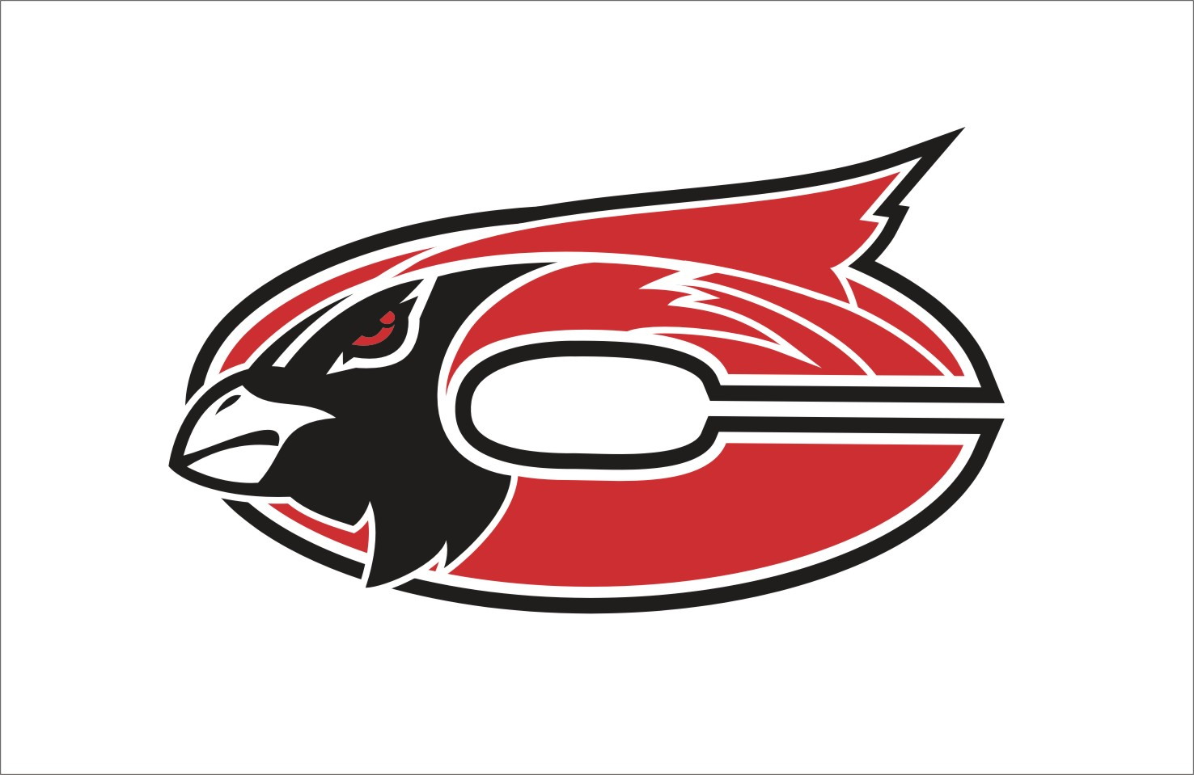

MISSION
The Faculty and staff of Chadwick R-1 Schools in partnership with parents and the community, will establish high standards of learning and high expectations for achievement while providing comprehensive guidance for success.

Subject:
Art
Grade Level:
2nd Grade

Grade:2 Subject: Art

Time Period | GLE/  MO Standard/  Common Core | Description | Notes--
August: Lines and shapes- should be review from 1st grade.

August | GLEs:  Strand II: 1A  Strand II: 1B  MO STANDARDS:  FA 2  DOK:  Level 1  Level 2  Level 3  Level 4  CC Standards for English/Writing:  RI 1,4  SL 1,2,3 | Non-Objective Art- Oil Pastel/Chalk  - Understand the term “non-objective artwork”  - Create a non-objective artwork  - Identify and use zigzag, dotted, and wavy lines.  - Identify and use geometric shapes.  - Blend chalk evenly to fill a space  Pre-Project Assessment:  - Pre-test paper on lines and shapes  - Question/Answer as class  Mid-Project Assessment:  - Question/Answer time with individual students as they work on project  Post-Project Assessment:  - Finished project  - Share time and discussion with class
September: Continue lines and shapes. Introduce color.

September | GLEs:  Strand I: 1D  Strand II: 1A  Strand II: 1B  Strand IV: 2A  Strand V: 1A  MO STANDARDS:  FA 1  FA 2  FA 4  FA 5  DOK:  Level 1  Level 2  Level 3  Level 4  CC Standards for English/Writing:  RI 1,4  SL 1,2,3 | Line and Shape-Paper Weaving  - Create a paper weaving using plain weave (over one, under one, alternating rows)  - Identify and use zigzag, dotted, and wavy lines.  - Identify and use geometric shapes.  - Relate to weavings from Native American Peoples  Pre-Project Assessment:  - Review with class on Smart board  - Question/Answer time  Mid-Project Assessment:  - Conference with students individually as they work on projects –ask questions  Post-Project Assessment:  - Finished project  - Question/Answer  - Share time and discussion with class
September | GLEs:  Strand I: 1B  Strand I: 3C  MO STANDARDS:  FA 1  DOK:  Level 1  Level 2  CC Standards for English/Writing:  SL 1,2,3 | Nature Color Wheel  - Paint lines with control of the brush  - Clean paint brush before changing colors  - Mix two colors to create a third color  - Create an artwork dealing with nature  - Create a color wheel design  - Identify and use primary and secondary colors  Pre-Project Assessment:  - Pre-project coloring sheet to determine if students know what colors combine to make other colors  - Question/Answer as a group  Mid-Project Assessment:  - Conference with students individually as I circulate around room  Post-Project Assessment:  - Finished project  - Question/Answer as group and individually  - Fill out the pre-project coloring sheet again to see if improvement
October: Continue Color. Introduce forms and value.

October | GLEs:  Strand II: 1C  Strand I: 1B  Strand II: 1E  MO STANDARDS:  FA 1  FA 2  DOK:  Level 1  Level 2  CC Standards for English/Writing:  SL 1,2,3 | Colors Meet Forms  - Identify and use geometric forms: sphere, cube, cylinder, and cone.  - Apply tempera paint in an even coat and produce a clear edge between colors  - Mix colors to produce other colors  - Identify and Use Secondary colors  Pre-Project Assessment:  - Question/Answer as group  Mid-Project Assessment:  - Conference with individual students during work time  - Question/Answer  Post-Project Assessment:  - Finished project  Question/Answer
October | GLEs:  Strand I: 1A  Strand I: 3A  Strand II: 1F  MO STANDARDS:  FA 1  FA 2  DOK:  Level 1  Level 2  CC Standards for English/Writing:  SL 1,2,3 | Shaded Pumpkin Drawings  - Use pressure to create multiple values using pencil and colored pencil  - Create a still life drawing of pumpkins  - Use value to create form  Pre-Project Assessment:  - Question/Answer  Mid-Project Assessment:  - Conference with individual students while they work  Post-Project Assessment:  - Finished project  - Share time and discussion with other students –present projects to others and explain
October | GLEs:  Strand I: 3B  Strand I: 3C  Strand II: 1C  MO STANDARDS:  FA 1  FA 2  DOK:  Level 1  Level 2  Level 3  Level 4  CC Standards for English/Writing:  SL 1,2,3 | Perfect House Drawing/Sculpture  - Design a building that serves a function in the community and includes building parts (e.g., roof, walls, door, windows, surface material)  - Create an artwork that communicates ideas about places (home)  - Identify and use geometric forms: sphere, cube, cylinder, and cone.  - Manipulate and use paper and other materials to create a sculpture  Pre-Project Assessment:  - Review on Smart Board  - Question/Answer  Mid-Project Assessment:  - Question/Answer  - Conference with individual students as the work  Post-Project Assessment:  - Finished project  - Question/Answer  - Share time and discussion with class- each student presents project and explanation to class
November: Start Cultural Unit.

November | GLEs:  Strand II: 2D  Strand IV: 2A  Strand V: 1A  MO STANDARDS:  FA 2  FA 4  FA 5  DOK:  Level 1  Level 2  Level 3  Level 4  CC Standards for English/Writing:  RI 1,4  SL 1,2,3 | Native American Molas  - Create a Native American Mola Design  - Relate Native American Culture to artwork  - Create a complex pattern  Pre-Project Assessment:  - Question/Answer  Mid-Project Assessment:  - Conference with individual students as necessary during work time  Post-Project Assessment:  - Finished project  - Share time/Presentation of projects by students /Discussion as a class
November | GLEs:  Strand I: 1B  Strand II: 1F  MO STANDARDS:  FA 1  FA 2  DOK:  Level 1  Level 2  Level 4  CC Standards for English/Writing:  SL 1,2,3 | Tints and Shades Turkeys  - Identify and Use tints and shades (light and dark values)  - Paint lines with control of brush  - Clean brush before changing colors  - Mix 2 colors to create a 3rd one  Pre-Project Assessment:  - Question/Answer as group  Mid-Project Assessment:  - Conference with individual students as necessary during project  Post-Project Assessment:  - Finished project  - Share time/Presentation of projects by students /Discussion as a class
November | GLEs:  Strand V: 1A  MO STANDARDS:  FA 5  DOK:  Level 1  Level 2  Level 3  Level 4  CC Standards for English/Writing:  RI 1,4  SL 1,2,3 | Thanksgiving Quilt Design  - Relate to American made Quilts- artist - Faith Ringgold  - Create a quilt design that reflects a Thanksgiving theme.  - Use lines and shapes to create patterns in border  Pre-Project Assessment:  - Question/Answer  - Pattern pre-project worksheet  Mid-Project Assessment:  - Question/Answer  - Conference with students individually as they work  Post-Project Assessment:  - Finished project  - Share time/Presentation of projects by students /Discussion as a class
December: Continue Cultural Unit. Talk about balance. Explore music and its relationship to art.

December | GLEs:  Strand IV: 2A  Strand V: 1A  MO STANDARDS:  FA 4  FA 5  DOK:  Level 1  Level 2  Level 3  Level 4  CC Standards for English/Writing:  RI 1,4  SL 1,2,3 | Symmetrical Mask- Native American Influence  - Fold paper to create identical halves  - Create a symmetrical design  - Understand the word “symmetry”  - Recognize Native American Influence in masks  - Explain the connection between Indian culture and art  Pre-Project Assessment:  - Question/Answer  Mid-Project Assessment:  - Worksheet on symmetry  - Conference with individual students as necessary during work time  Post-Project Assessment:  - Finished project  - Share time/Presentation of projects by students /Discussion as a class
December | GLEs:  Strand IV: 1A  MO STANDARDS:  FA 4  DOK:  Level 1  Level 2  CC Standards for English/Writing:  SL 1,2,3 | Patterns in Music and art- Maracas  - Compare patterns in music to patterns in artwork  - Identify music and art from several different cultures  - Create a homemade musical instrument  Pre-Project Assessment:  - Question/Answer  - Class chart about relationship between music/art  Mid-Project Assessment:  - Conference with individual students as necessary during work time  Post-Project Assessment:  - Finished project  - Share time/Presentation of projects by students /Discussion as a class
December | Varies | Christmas Projects
January: Continue cultural unit. Introduce texture and relief.

January | GLEs:  Strand II: 1D  MO STANDARDS:  FA 2  DOK:  Level 1  Level 2  Level 4  CC Standards for English/Writing:  SL 1,2,3 | Textured Creatures  - Identify and Use actual texture  - Create a collage picture using textures  - Relate textures to books by Eric Carle  Pre-Project Assessment:  - Question/Answer  - Class contributed list on board of texture words  Mid-Project Assessment:  - Conference with individual students as necessary during work time  Post-Project Assessment:  - Finished project  - Share time/Presentation of projects by students /Discussion as a class
January | GLEs:  Strand I: 2A  Strand II: 1D  Strand II: 2C  MO STANDARDS:  FA 1  FA 2  DOK:  Level 1  Level 2  Level 3  Level 4  CC Standards for English/Writing:  SL 1,2,3 | Textured Windsocks  - Define and use actual texture  - Identify and describe different types of textures  - Create a relief artwork from cut paper  - Use color contrast  Pre-Project Assessment:  - Question/Answer  - Texture chart as class  Mid-Project Assessment:  - Conference with individual students as necessary during work time  Post-Project Assessment:  - Finished project  - Share time/Presentation of projects by students /Discussion as a class
January | GLEs:  Strand I: 2A  Strand II: 1B  Strand II: 1A  Strand V: 1A  MO STANDARDS:  FA 1  FA 2  FA 5  DOK:  Level 1  Level 2  Level 3  Level 4  CC Standards for English/Writing:  RI 1,4  SL 1,2,3 | Mummy Case Relief  - Manipulate paper to create low relief – Mummy Case Design  - Identify and Use zigzag, dotted, and wavy lines  - Identify and Use Geometric shapes  - Become familiar with the Egyptian culture  - Know why Egyptian mummified their dead  - Become familiar with hieroglyphic writing  - use symmetry in the creation of their mummy case  Pre-Project Assessment:  - Question/Answer  Mid-Project Assessment:  - Conference with individual students as necessary during work time  Post-Project Assessment:  - Finished project  - Share time/Presentation of projects by students /Discussion as a class
February: Misc. Lessons. Clay.

February | GLEs:  Strand II: 1A  Strand II: 1B  Strand II: 2D  Strand V: 1A  MO STANDARDS:  FA 2  DOK:  Level 1  Level 2  Level 4 | Ancient Egyptian Collars, Cuffs, Headdress  - Create wearable art based on a cultural example  - Identify wearable art and other artworks from Egypt  - Use a variety of lines, shapes and patterns  - Create complex patterns  Pre-Project Assessment:  - Question/Answer  Mid-Project Assessment:  - Conference with individual students as necessary during work time  Post-Project Assessment:  - Finished project  - Share time/Presentation of projects by students /Discussion as a class
February | GLEs:  Strand II: 1G  Strand II: 1D  MO STANDARDS:  FA 2  DOK:  Level 1  Level 2  Level 3  Level 4  CC Standards for English/Writing:  SL 1,2,3 | Hide and Seek Animals  - Create an artwork showing nature  - Identify and use texture to create a drawing  - Show space  Pre-Project Assessment:  - Question/Answer  Mid-Project Assessment:  - Conference with individual students as necessary during work time  Post-Project Assessment:  - Finished project  - Share time/Presentation of projects by students /Discussion as a class
February | GLEs:  Strand I: 2A  MO STANDARDS:  FA 1  DOK:  Level 1  Level 2  Level 3  Level 4  CC Standards for English/Writing:  SL 1,2,3 | Coiled Heart Coasters  - Modeling with clay or a similar material: Roll coils  - Create a heart shape from a series of coils  - Add textures to clay using a toothpick to create designs  Pre-Project Assessment:  - Question/Answer  Mid-Project Assessment:  - Conference with individual students as necessary during work time  Post-Project Assessment:  - Finished project  - Share time/Presentation of projects by students /Discussion as a class
March: Misc. Spring Lessons. Still Life. Pointillism.

March | GLEs:  Strand I: 3A  MO STANDARDS:  FA 1  DOK:  Level 1  Level 2  Level 4  CC Standards for English/Writing:  SL 1,2,3 | Toy Shop Shelf  - Create a still life from observation  Pre-Project Assessment:  - Question/Answer  Mid-Project Assessment:  - Conference with individual students as necessary during work time  Post-Project Assessment:  - Finished project  - Share time/Presentation of projects by students /Discussion as a class
March | GLEs:  Strand I: 3C  MO STANDARDS:  FA 1  DOK:  Level 1  Level 2  Level 3  Level 4  CC Standards for English/Writing:  RI 1,4  SL 1,2,3 | Pointillism Butterfly  - Show an item from nature  - Use pointillism to create a unique design  - Identify pointillist artwork- Pissarro  Pre-Project Assessment:  - Question/Answer  Mid-Project Assessment:  - Conference with individual students as necessary during work time  Post-Project Assessment:  - Finished project  - Share time/Presentation of projects by students /Discussion as a class
March | GLEs:  Strand I: 3C  Strand II: 1F  MO STANDARDS:  FA 1  FA 2  DOK:  Level 1  Level 2  Level 4  CC Standards for English/Writing:  RI 1  SL 1,2,3 | Georgia O’Keefe Flowers  - Create a design from nature  - Identify the works of Georgia O’Keefe  - Create a flower design using chalk  - Use light and Dark values  Pre-Project Assessment:  - Question/Answer  Mid-Project Assessment:  - Conference with individual students as necessary during work time  Post-Project Assessment:  - Finished project  - Share time/Presentation of projects by students /Discussion as a class
March | GLEs:  Strand I: 1B  Strand I: 3A  Strand I : 3C  Strand II: 1G  MO STANDARDS:  FA 1  FA 2  DOK:  Level 1  Level 2  Level 4  CC Standards for English/Writing:  SL 1,2,3 | Landscape Watercolor  - Identify and Use Foreground, Middle ground, and Background  - Create an original landscape painting  - Use a variety of lines  - Paint lines with control of the brush.  - Clean paintbrush before changing colors.  Pre-Project Assessment:  - Question/Answer  Mid-Project Assessment:  - Conference with individual students as necessary during work time  Post-Project Assessment:  - Finished project  - Share time/Presentation of projects by students /Discussion as a class
April: Talking about Art. Art Criticism.

April | GLEs:  Strand V: 1B  Strand V: 1A  Strand III: 2A  Strand III: 1A  MO STANDARDS:  FA 3  FA 5  DOK:  Level 1  Level 2  Level 3  Level 4  CC Standards for English/Writing:  RI 1,4, 5  W 1,2,8  SL 1,2,3  L 6 | Art Criticism- Talking about Art – Review  - Compare and contrast two artworks on: Subject matter, Media ,Use of line, color, shape, and texture, Theme -Purpose of art in culture  - Identify works of art from: United States, Native American, Egypt  - Identify the following in artworks: Geometric shapes, Geometric forms, Foreground and back-ground, Real textures, Contrast  - Explain the different responses to different artworks  Pre-Project Assessment:  - Question/Answer  - Class Example  Mid-Project Assessment:  - Conference with individual students as necessary during work time  Post-Project Assessment:  - Finished Criticism
April |  | Additional Projects – Review
May:

