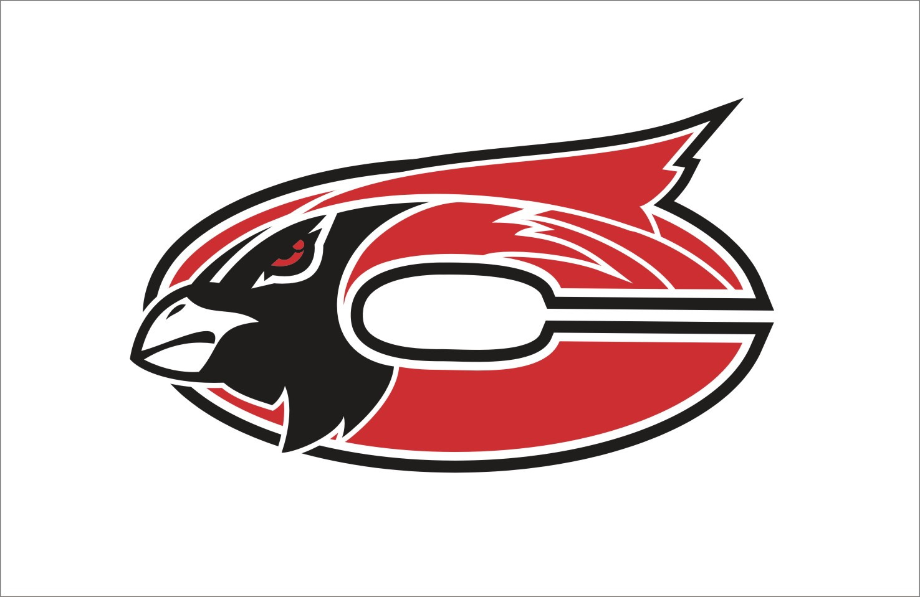

MISSION
The Faculty and staff of Chadwick R-1 Schools in partnership with parents and the community, will establish high standards of learning and high expectations for achievement while providing comprehensive guidance for success.

Subject:
Art
Grade Level:
1st Grade

Grade: Subject:

Time Period | GLE/  MO Standard/  Common Core | Description | Notes--
August: Introduction to Lines, Shapes, Symmetry.

August | GLEs:  Strand II: 2A  Strand II :1A  Strand II : 1B  Strand I: 2A  Strand I: 1A  MO STANDARDS:  FA 1  FA 2  DOK:  Level 1  Level 2  CC Standards for English/Writing:  SL 1,2,3,4,5  L 5 | Symmetrical Butterfly with Lines and Shapes  - Fill an area with solid color/value using crayon, pencil, or marker.  - Fold paper and identify folded edge  - Identify and use straight, curved, thick, and thin lines.  - Identify and use triangle, circle, square, rectangle, and oval shapes.  - Categorize shapes as small, medium, and large.  - Identify and demonstrate the concept of middle or center.  Pre-Project Assessment:  - Question/Answer  - Discussion as group  Mid-Project Assessment:  - Question/Answer time with students individually as I go around room  - Ask students to identify lines, shape, patterms, size, middle of artwork and ask them to explain symmetry  Post-Project Assessment:  - Finished Project  - Question/answer  Share time and discussion with class
September: Color Unit

September | GLEs:  Strand I: 2A  Strand I: 3C  Strand II: 1E  MO STANDARDS:  FA 1  FA 2  DOK:  Level 1  Level 3  Level 4  CC Standards for English/Writing:  SL 1,2,3,4,5  L 5 | Primary Color Superhero Collage  - Identify and Use the Primary Colors  - Create a superhero  Pre-Project Assessment:  - Question/answer as group  - Primary color worksheet  Mid-Project Assessment:  - Question/Answer time with students individually as I go around room  Post-Project Assessment:  - Finished project  - Question/answer  - Share time and discussion as class
September | GLEs:  Strand I: 3C  MO STANDARDS:  FA 1  DOK:  Level 1  Level 2  Level 3  Level 4  CC Standards for English/Writing:  W 2,3  SL 1,2,3,4,5 | Comic Strips about Primary Color Super Hero  - Create a comic strip showing a series of events  - Create an original artwork that communicates ideas about people  Pre-Project Assessment:  - Question/Answer as group  Mid-Project Assessment:  - Question/Answer time with students individually as I go around room  Post-Project Assessment:  - Finished Project  - Color Quiz  - Share time and discussion as a class
September | GLEs:  Strand I: 2A  Strand I: 3C  Strand II: 1E  MO STANDARDS:  FA 1  FA 2  DOK:  Level 1  Level 2  CC Standards for English/Writing:  SL 1,2,3,4,5  L 5 | Color Mixing- LadyBugs  - Student will identify primary and secondary colors  - Students will learn and understand which primary colors are mixed to make each of the secondary colors by matching pieces of the ladybugs together  - Use glue with control  Pre-Project Assessment:  - Question/ answer as a class  - Have students hold up colors as an answer to teacher questions  Mid-Project Assessment:  - Question/ Answer time with students individually as I go around room  Post-Project Assessment:  - Finished project  - Question/Answer  - Share time and discussion as class
September | GLEs:  Strand I: 1B  Strand II: 1E  MO STANDARDS:  FA 1  FA 2  DOK:  Level 1  Level 2  CC Standards for English/Writing:  SL 1,2,3,4,5  L 5 | How to Mix Paint  - Student will understand the process of proper painting.  - Student will know how to properly mix paints to create secondary and intermediate colors from primary colors.  Pre-Project Assessment:  - Question/ answer as a class  - Have students demo properly holding brush, etc.  Mid-Project Assessment:  - Question/ Answer time with students individually as I go around room  Post-Project Assessment:  - Finished project  - Question/Answer  - Paint mixed worksheet quiz  - Share time and discussion as class
October: Continue Color Unit. Introduce Ancient Art forms.

October | GLEs:  Strand I: 1A  Strand I: 3A  Strand I: 3C  Strand II: 1F  MO STANDARDS:  FA 1  FA 2  DOK:  Level 1  Level 2  Level 4  CC Standards for English/Writing:  SL 1,2,3,4,5  L 5 | Shaded Pumpkin Drawings  - Identify and Use Value to create a shaded drawing of a pumpkin  - Create a still life drawing  Pre-Project Assessment:  - Question/ Answer as group  Mid-Project Assessment:  - Question/Answer time with individual students as I go around  Post-Project Assessment:  - Finished project  - Share time and discussion as class
October | GLEs:  Strand V: 1A  Strand III: 2A  Strand I : 3C  Strand II: 1D  MO STANDARDS:  FA 1  FA 2  FA 3  FA 5  DOK:  Level 1  Level 2  Level 4  CC Standards for English/Writing:  RI 1,2,3,4,6  SL 1,2,3,4,5 | Cave Art  - Identify Cave art from Lascaux Cave in France  - Produce their own version of cave art  - Their cave art should tell people of the future about themselves.  - Identify and use neutral colors  - Find a common theme in cave art  - Identify and use texture  Pre-Project Assessment:  - Cave Art Pre-lesson worksheet  - Question/answer as group  Mid-Project Assessment:  - Question/Answer time with students individually as I go around  Post-Project Assessment:  - Finished project  - Share time and discussion with class  - “What I learned” Activity sheet
October | Varies | Halloween Projects
November: Continue learning about ancient art forms from a variety of cultures. Varied art mediums.

November | GLEs:  Strand V: 1A  Strand II: 1G  Strand I: 3C  Strand I: 1A  MO STANDARDS:  FA 1  FA 2  FA 5  DOK:  Level 1  Level 2  Level 4  Level 4  CC Standards for English/Writing:  RI 1,2,4  SL 1,2,3,4,5  L 5 | Greek Vases  - Identify Greek Pottery  - Identify positive and negative space  - Use positive and negative space to create their own Greek style “pottery”  - Create a crayon resist  Pre-Project Assessment:  - Question/answer as group  Mid-Project Assessment:  - Question/Answer time with individual students, ask students to explain how and where they are using positive and negative space as well as why they made those choices  Post-Project Assessment:  - Finished project  - Presentation of projects to class with explanation  - Question/answer individual and as group
November | GLEs:  Strand I: 2A  Strand II:1C  Strand II: 2A  MO STANDARDS:  FA 1  FA 2  DOK:  Level 1  Level 2  CC Standards for English/Writing:  SL 1,2,3,4,5 | Pinch Pots  - Identify and Use Form  - Pinch, pull, and roll clay  - Create a pinch pot  Pre-Project Assessment:  - Question/answer as group  Mid-Project Assessment:  - Question/Answer time with individual students as they work  Post-Project Assessment:  - Finished project  - Question/answer individual and as group
November | GLEs:  Strand II: 1D  MO STANDARDS:  FA 2  DOK:  Level 1  Level 2 | Leaf Rubbings  - Identify and use texture to create a leaf rubbing  Pre-Project Assessment:  - Question/answer as group  Mid-Project Assessment:  - Question/Answer time with individual students as they work  Post-Project Assessment:  - Finished project  - Question/answer individual and as group
November | Varies | Thanksgiving Projects
December: Working with Space.

December | GLEs:  Strand II: 1A  Strand II: 1B  Strand II: 1G  Strand IV: 2A  Strand II: 2D  MO STANDARDS:  FA 2  FA 4  DOK:  Level 1  Level 2  Level 3  Level 4  CC Standards for English/Writing:  SL 1,2,3,4,5  L 5 | Jazzy Jungle Trees  - Identify and use foreground, middle ground, and background to create space  - Identify and use patterns, lines, and shapes to create an interesting composition  - Explain how patterns in art are similar to patterns in math  Pre-Project Assessment:  - Question/answer as group  Mid-Project Assessment:  - Question/Answer time with individual students  - Have students point out lines, shapes, patterns, foreground, middleground and background as they work on projects and discuss  Post-Project Assessment:  - Finished project  - Presentation of projects to class with explanation  - Question/answer as individual and as group
December | Varies | Christmas Cards
January: Create artworks using themselves and others as subject matter.

January | GLEs:  Strand I: 3B  Strand I: 3C  MO STANDARDS:  FA 1  DOK:  Level 1  Level 2  Level 3  Level 4  CC Standards for English/Writing:  SL 1,2,3,4,5  L 5 | Ties  - Create a Tie Design representing themselves and their families  Pre-Project Assessment:  - Question/Answer time as class  Mid-Project Assessment:  - Question/Answer time with individual students  - Ask students for explanation of why they are doing what they are doing  Post-Project Assessment:  - Finished project  - Share time and discussion with class
January | GLEs:  Strand I: 2A  Strand I: 3A  Strand I: 3C  Strand II: 1A  Strand II: 1B  Strand V: 1A  MO STANDARDS:  FA 1  FA 2  FA 5  DOK:  Level 1  Level 2  Level 4  CC Standards for English/Writing:  SL 1,2,3,4,5  L 5 | Family Portrait Quilt Squares  - Create a quilt square showing family members  - Identify and use lines and shapes to create a border  - Use glue with control  - Identify Quilts-idea of family quilts from United States  Pre-Project Assessment:  - Question/answer as group  Mid-Project Assessment:  - Question/Answer time with individual students  Post-Project Assessment:  - Finished project  - Presentation of projects to class with explanation  - Question/answer individual and as group
January | GLEs:  Strand I: 2A  Strand I: 3C  Strand V: 1A  MO STANDARDS:  FA 1  FA 5  DOK:  Level 1  Level 2  Level 3  Level 4  CC Standards for English/Writing:  RI 1,2,3,4,6  SL 1,2,3,4,5  L5 | Family Crests  - Create a family crest  - Recognize the history and purpose behind a family crest –relate to Europe  - Create a design that reflects themselves and their family by compiling pictures to show family interests/descriptors  - Cut a symmetrical shape from paper  - Fold paper and identify the folded edge  Pre-Project Assessment:  - Question/answer as group  Mid-Project Assessment:  - Question/Answer time with individual students  Post-Project Assessment:  - Finished project  - Presentation of projects to class with explanation  - Question/answer individual and as group
January | GLEs:  Strand I: 2A  Strand II:1C  MO STANDARDS:  FA 1  FA 2  DOK:  Level 1  Level 2  Level 4  CC Standards for English/Writing:  SL 1,2,3,4,5  L 5 | Modeling Clay Sculptures  - Identify and Use Form  - Pinch, pull, and roll clay  Pre-Project Assessment:  - Question/answer as group  Mid-Project Assessment:  - Question/Answer time with individual students as they work  Post-Project Assessment:  - Finished project  - Presentation of projects to class with explanation  - Question/answer individual and as group
February: Varied Projects. Symmetry. Mask Making. Paper Jewelry. Additive Process.

February | GLEs:  Strand I: 3A  Strand I: 3C  Strand II: 1D  MO STANDARDS:  FA 1  FA 2  DOK:  Level 1  Level 2  Level 3  CC Standards for English/Writing:  SL 1,2,3,4,5  L 5 | Toy Store Window  - Create a still life with a series of objects  - Identify and Use texture  Pre-Project Assessment:  - Question/answer as group  Mid-Project Assessment:  - Question/Answer time with individual students  Post-Project Assessment:  - Finished project  - Presentation of projects to class with explanation  - Question/answer individual and as group
February | GLEs:  Strand I: 3B  MO STANDARDS:  FA 1  DOK:  Level 1  Level 2  Level 4  CC Standards for English/Writing:  RI 1,2,4,6  SL 1,2,3,4,5  L 5 | Masquerade Masks  - Students will know the origin and the meaning of Masquerade Masks.  - Students will know the location of Venice, Italy and the term Gondola.  - Students will understand the process of making a Masquerade Mask.  Pre-Project Assessment:  - Class chart about knowledge of masks done on SmartBoard  - Question/Answer  Mid-Project Assessment:  - Question/Answer time with individual students as they work  - Have students explain why they have made artistic choices they have made and how those choices meet objectives  Post-Project Assessment:  - Finished project  - Question/Answer  - Share time and discussion with group
February | GLEs:  Strand I: 2A  Strand I: 3B  Strand I: 3C  Strand II: 1A  Strand II: 1B  Strand II: 2A  Strand V: 1A  Strand IV: 1A  MO STANDARDS:  FA 1  FA 2  FA 4  FA 5  DOK:  Level 1  Level 2  Level 3  Level 4  CC Standards for English/Writing:  RI 1,2,4,6  SL 1,2,3,4,5  L 5 | Symmetrical Masks with Asian Influence  - Fold paper and identify folded edge  - Identify and use lines and shapes  - Identify and demonstrate the concept of middle or center.  - Create a mask design  - Relate costume piece to clothing design  Pre-Project Assessment:  - Question/answer as group  Mid-Project Assessment:  - Question/Answer time with individual students  Post-Project Assessment:  - Finished project  - Presentation of projects to class with explanation  - Question/answer individual and as group
February | GLEs:  Strand I: 2A  Strand I: 3B  Strand I: 3C  MO STANDARDS:  FA 1  DOK:  Level 1  Level 2  Level 4  CC Standards for English/Writing:  RI 1,4,6  SL 1,2,3,4,5  L 5 | African Necklaces –Paper Jewelry  - Manipulate paper to create “beads” for necklace  - Create Wearable art  Pre-Project Assessment:  - Question/answer as group  Mid-Project Assessment:  - Question/Answer time with individual students  - Check student progress as I rotate around room  Post-Project Assessment:  - Finished project  - Question/answer individual and as group
March: Varied Projects. Review through talking about art.

March | GLEs:  Strand I: 2A  Strand I: 3C  Strand II: 1A  Strand II: 1B  Strand V: 1A  MO STANDARDS:  FA 1  FA 2  FA 5  DOK:  Level 1  Level 2  Level 4  CC Standards for English/Writing:  RI 1,4  SL 1,2,3,4,5  L 5 | Carp Kites  - Create a Karp Kite  - Identify Japanese Kite designs  - Learn about Japanese Children’s Day  - Identify and use lines and shapes to create a design for kite  Pre-Project Assessment:  - Question/answer as group  Mid-Project Assessment:  - Question/Answer time with individual students  Post-Project Assessment:  - Finished project  - Presentation of projects to class with explanation  - Question/answer individual and as group
March | GLEs:  Strand III: 1A  Strand III: 2A  Strand V: 1B  MO STANDARDS:  FA 3  FA 5  DOK:  Level 1  Level 2  Level 3  Level 4  CC Standards for English/Writing:  RI 1 ,3,4,5,6  W 1,2  SL 1,2,3,4,5  L 5 | Talking About Art  - Identify lines, shapes, colors and patterns in an artwork  - Relate their feelings to an artwork, explain what kinds of feelings they get from viewing a particular artwork  - Compare and Contrast 2 works of art  Pre-Project Assessment:  - Question /Answer as class  - Venn diagram as class- compare and contrast  Mid-Project Assessment:  - Question/Answer time with individual students as they work  Post-Project Assessment:  - Finished project  - Question/Answer
March | GLEs:  Strand I: 1D  Strand I: 2A  Strand II: 1E  MO STANDARDS:  FA 1  FA 2  DOK:  Level 1  Level 2  Level 4  CC Standards for English/Writing:  SL 1,2,3,4,5  L 5 | Printmaking- Monoprint Butterflies  - Create Mono print butterflies  - Identify and Use Primary and Secondary Colors  - Identify Folded Edge of paper  - Use glue with control  - Create a creative flower garden for mono-print butterflies to live in  Pre-Project Assessment:  - Question/Answer as group  - Review as group  Mid-Project Assessment:  - Question/Answer time with students individually as I go around  Post-Project Assessment:  - Finished project  - Color “quiz”  Share time and discussion with class
April:

April | Varies | Additional Review Projects
May:

May

